**CUSTOMER FEEDBACK REPORT**

A MINI PROJECT REPORT SUBMITTED BY

Shrilakshmi Pai N Ramya

4NM18CS183 4NM19CS414

VI Semester, D Section VI Semester, D section

UNDER THE GUIDANCE OF

Ms. Keerthana B

Assistant professor Gd II

Department of Computer Science and Engineering

IN PARTIAL FULFILLMENT OF THE REQUIREMENTS FOR THE AWARD OF THE DEGREE OF

Bachelor of Engineering in Computer Science & Engineering

from

Visvesvaraya Technological University, Belagavi



N.M.A.M. INSTITUTE OF TECHNOLOGY

(An Autonomous Institution under VTU, Belgaum)

AICTE approved, (ISO 9001:2015 Certified), Accredited with ‘A’ Grade by NAAC NITTE -574 110, Udupi District, KARNATAKA.

DEPARTMENT OF COMPUTER SCIENCE AND ENGINEERING



(ISO 9001:2015 Certified), Accredited with ‘A’ Grade by NAAC

🕿: 08258 - 281039 – 281263, Fax: 08258 – 281265

## Department of Computer Science and Engineering

**CERTIFICATE**

“CUSTOMER FEEDBACK REPORT” is a bonafide work carried out by Shrilakshmi Pai N (4NM18CS183) and Ramya(4NM19CS414) in partial fulfilment of the requirements for the award of Bachelor of Engineering Degree in Computer Science and Engineering prescribed by Visvesvaraya Technological University, Belagavi during the year 2021-2022.

It is certified that all corrections/suggestions indicated for Internal Assessment have been incorporated in the report. The Mini project report has been approved as it satisfies the academic requirements in respect of the project work prescribed for the Bachelor of Engineering Degree.

Signature of Guide Signature of HOD

# ACKNOWLEDGEMENT

We believe that our project will be complete only after we thank the people who have contributed to make this project successful.

First and foremost, our sincere thanks to our beloved principal, Dr. Niranjan N. Chiplunkar for giving us an opportunity to carry out our project work at our college and providing us with all the needed facilities.

We sincerely thank Dr. K.R. Udaya Kumar Reddy, Head of Department of Computer Science and Engineering, Nitte Mahalinga Adyantaya Memorial

Institute of Technology, Nitte.

We express our deep sense of gratitude and indebtedness to our guide Ms. Keerthana B, Assistant Professor Gd II, Department of Computer Science and Engineering, for her inspiring guidance, constant encouragement, support and suggestions for improvement during the course of our project.

We thank all the teaching and non-teaching staff members of the Computer Science and Engineering Department and our parents and friends for their honest opinions and suggestions throughout the course of our project.

Finally, we thank all those who have supported us directly or indirectly throughout the project and making it a grand success.

Shrilakshmi Pai N

(4NM18CS183)

Ramya

(4NM19CS414)

**CUSTOMER FEEDBACK REPORT**

# **ABSTRACT**

Purpose – Adopting the transformative service research (TSR) perspective, the purpose of this paper is to investigate the impact of positive customer feedback on the well-being of front-line employees, companies, and society. Using a multidisciplinary approach, the overlooked area of “positive feedback” is explored resulting in the development of the “Positive Feedback Model” (PFM). The study also compares managers’ and employees’ perceptions of positive customer feedback. Design/methodology/approach – Two exploratory qualitative studies were conducted: Study 1 consisted of 22 semi-structured interviews with managers working in the service industry and Study 2 consisted of seven focus groups with front-line service employees. The extensive literature review and the results of these two studies contributed to the development of the PFM. Findings – Positive customer feedback is an overlooked area of service research which offers potential for improving the well-being of the service entities. Front-line employees are the main recipients and topics of positive customer feedback. The developed PFM describes various forms, channels, and times of administration of positive customer feedback and its multitude of impacts on the well-being of service entities. Research limitations/implications – This study contributes to the literature on TSR and customer feedback management. The developed model presents possible positive feedback categories, their various outcomes and the outcomes for the concerned parties involved. By developing PFM and encouraging a multidisciplinary approach combined with advanced research methodologies, the researchers propose an agenda for further research insights within the TSR and customer feedback areas. The comparison of the managers’ and employees’ perceptions of positive customer feedback presents novel managerial implications and directions for future research. Originality/value – This study is the first to explore customer feedback from a TSR perspective. It examines the overlooked area of positive customer feedback. The well-being of service entities is prioritized as services have been extensively criticized for ignoring human well-being.

Table of Contents

**S.No | Title | Page No.**

**----------------------------------------------------------------------------------**

1. Introduction ------------------ 3

1. Literature Survey -------------------- 4
2. Design and analysis------------------ 5

1. Implementation ------------------- 6 – 7
2. Results ---------------------
3. Conclusion -------------------- 8

7 References ------------------------- 9

introduction

We’ve achieved so many great things this year however, it’s one of our challenges to make sure that we respond to and manage rising customer expectations and demands, but also recognise the opportunities this presents. To achieve this we need to listen to your feedback, manage expectations and continuously improve our services. This is why customer feedback (compliments, complaints, and comments) is important, and why it’s our aim to make sure that you feel able to provide us with feedback. We’re working hard to make sure you know how to do this and that we respond fairly and in partnership with you. We’ll aim to reach a swift resolution because putting you at the heart of our services is something we always consider. It’s vital to continuous service improvement to know when things have gone right and when people are happy with the services they receive. However, on those occasions when things go wrong, complaints are equally valuable. They provide a chance to identify errors and to make sure the same mistake is not repeated in the future. Not all customer concerns need to be processed as a complaint. When a customer has contacted the service direct and their concerns are resolved by the service there is no need to escalate these to the council’s complaints procedures. Therefore the information reported on below does not include these concerns unless the customer remained unhappy and pursued their concerns further. It’s important that we make sure the customer is always informed of their right to make a complaint if their concern is not resolved or they remain unhappy. The Customer Feedback and Improvement team, who are part of Customer Services, are responsible for the management, facilitation and collation of all customer feedback received for the council.

LITERATURE SURVEY

Customer satisfaction with career guidance: a literature review .

|  |  |
| --- | --- |
| Item Type | Research Report |
| Authors | Hooley, Tristram; Neary, Siobhan; Morris, Marian; Mackay, Susan |
| Citation | Hooley, T. et al (2016) 'Customer satisfaction with career guidance: a literature review' Derby: University of Derby |
| Download date | 29/05/2021 18:59:38 |
| Link to Item | http://hdl.handle.net/10545/606948 |

Design and analysis

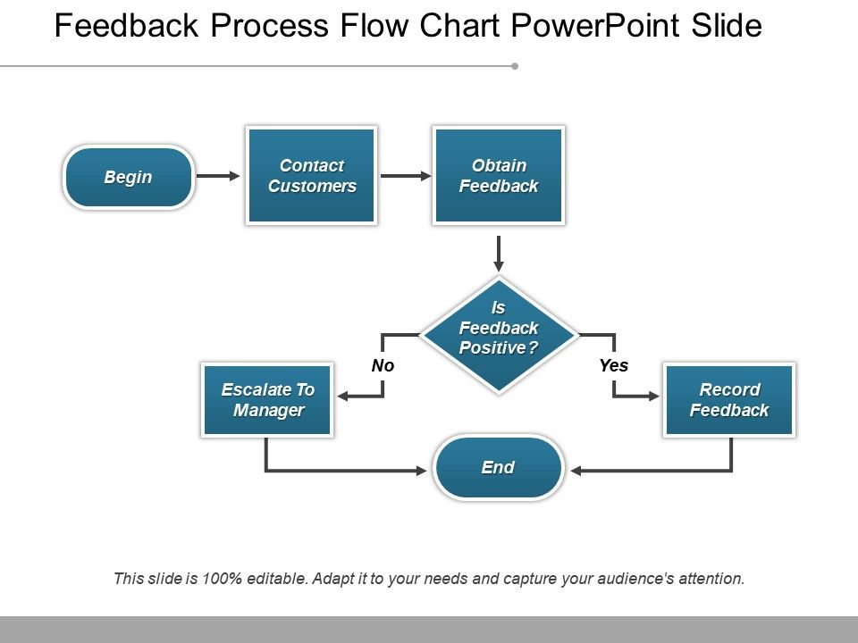

Feedback of any type is a productive element that determines the review and appraisal of any employee in an organization, the promotion or demotion of the employee in any company or candidate in any organization. The feedback process flow chart PowerPoint slide as shown here comprises of a flowchart design where the steps begin, contact customers, obtain feedback, feedback type- yes or no and then escalate to the manager if it is no and records it if it is yes, and finally end of it. Depending on the process with which it is associated, the feedback review system determines the end result. In the given case it is more of customer feedback PowerPoint presentation graphic. The entire flowchart has been designed in a very neat and clean manner. Ski along safely on our Feedback Process Flow Chart Powerpoint Slide. Conquer the steepest inclines with ease.

implementation

sample training data: Training.tvs

|  |
| --- |
| tag consumer_complaint_narrative |
|  | complaint The give me a room which was so smelly and the floor was wet, then they change me to another room which the power is not working the room, and had to wait 40 mins to change me to another room for the third time. | |
|  | meaningless Unfortunately there was a mix up with my Passport and Visa, and I couldn't get through customs at Charles de Gaulle. | |
|  | comment The (basic) room was comfortable and not too small. | |
|  | comment Our primary concierge, [name[, was amazing in his attitude of caring and willingness to help. | |
|  | complaint We booked through Priceline (paying more than listed price on hotel website). No one was at the desk when we arrived for about 10 minutes. | |
|  | comment Some are fairly easy, but I definitely get stuck. | |
|  | comment We had a perfect stay at this little boutique hotel. | |
|  | meaningless Same as previous comment. | |
|  | complaint My contact details have gone. | |
|  | comment It is a great tool, | |
|  | complaint At present not providing snacks evening time. | |
|  | comment Room, amenities, service, staff and spa were all WONDERFUL | |
|  | comment Well anything that make LIFE easier is worth a good rating, and they don't always leave instructional videos on line for ever so I can get it and watch it later. | |
|  | meaningless seems like they have problem with this kind of problem,the hotel it self did not make it right | |
|  | comment Hydrotherapy pool was amazing. | |
|  | comment the best one player ever I have before. | |
|  | request i want winsetup usb work with win8 | |
|  | complaint we had quite a bad first impression at our first stay! | |
|  | complaint Then you have to search for it again and doesn't even resume from where it stops. | |
|  | comment The Imperial Hotel uniquely combines these features with a modern touch. | |
|  | comment All round good experience but I'd say the hotel was a little out of our league. | |
|  | comment Nothing at all. | |
|  | comment Only the locayion was good | |
|  | complaint We're unable to see them as if they are sorted from Z to A. | |
| **Sample code:Train.py**  import os  import sys  import json  import time  import logging  import data_helper  import datetime  import numpy as np  import tensorflow as tf  from text_cnn import TextCNN  from tensorflow.contrib import learn  #from sklearn.model_selection import train_test_split  from sklearn.model_selection import train_test_split  logging.getLogger().setLevel(logging.INFO)  def train_cnn():  """Step 0: load sentences, labels, and training parameters"""  train_file = sys.argv[1]  x_raw, y_raw, df, labels = data_helper.load_data_and_labels(train_file)  parameter_file = sys.argv[2]  params = json.loads(open(parameter_file).read()) | |  |
|  | |  |
|  | |  |
|  | |  |
|  | |  |
|  | |  |
|  | |  |
|  | |
|  | |
|  | |
|  | |
|  | |
|  | |
|  | |
|  | |
|  | |

Conclusion

Despite the relatively limited extent of the literature, there are still a number of findings in this review that may be useful in informing the development of the National Careers Services and enhancing customer satisfaction. Firstly, it is important to note that all of the research in this area suggests that there is good reason to expect high degrees of customer satisfaction. The studies identified report overall satisfaction levels of between 70-89%. While the figures presented in Table 3 are not directly comparable with each other, the National Careers Service and its predecessor organisation in England seem to be reporting some of the higher levels of satisfaction (based on those who used the service and responded to requests for feedback). Consequently, if satisfaction with the service drops below 80%, there would be reasonable cause for concern. Conversely, if the service has ambitions to move customer satisfaction up to 90% or higher, it will be breaking new ground in achieving that level of satisfaction. It is likely that marginal differences in the levels of customer satisfaction between the studies examined in this paper can be accounted for, at least in part, by a variation in approaches to measurement. If the National Careers Service is to focus on maintaining or increasing levels of customer satisfaction, serious consideration should be given to the following issues: • Customers’ expectations about the nature of the career support they are going to receive have an impact on the level of satisfaction they report following the intervention. It is possible to influence these expectations before they receive an intervention and at the start of the intervention (contracting). • Different venues and providers of career support may have an impact on the levels of customer satisfaction that are reported. • Careers advisers’ satisfaction with their own jobs correlates with customer satisfaction. Attention to staff satisfaction may therefore have positive impacts on the experience of customers. • The working alliance between careers advisers and their customers is a critical determinant of customer satisfaction. This is comprised of three main elements: counsellor/client agreement about the goals of the interaction; their agreement about the tasks leading to these goals; and their emotional relationship. Attending to advisers’ skills in building positive working alliances is likely to be an important aspect of improving customer satisfaction.

References

* Capella, M. E., & Andrew, J. D. (2004). The relationship between counselor job satisfaction and consumer satisfaction in vocational rehabilitation. Rehabilitation Counseling Bulletin, 47(4): 205-214.
* Head of Defence Statistics Health (2014). Career Transition Partnership: Follow-Up Questionaire. Available from https://www.gov.uk/government/uploads/system/uploads/attachment_data/file/278852/ 20140211_CTP_Questionniare_responses_from_exServices_leavers.pdf (Accessed 26th February 2015)
* Howieson, C. & Semple, S. (2000). The evaluation of guidance: Listening to pupils' views. British Journal of Guidance & Counselling, 28(3): 373-387.